Optomatica’s GateID Asset Inventory

We have a Virtual Private Cloud (VPC) on Huawei Cloud in Egypt.

Its public IP is 101.46.67.133

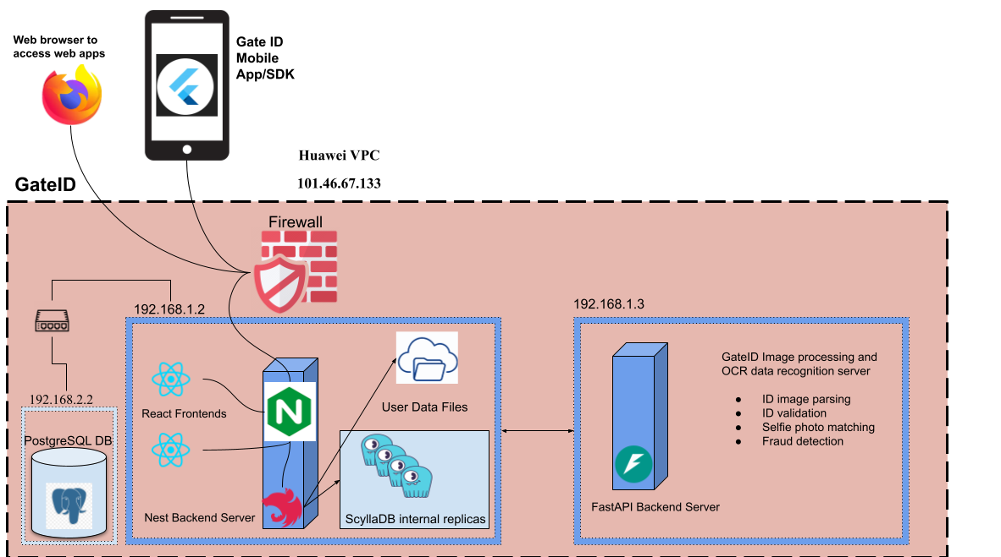

# 

# GateID VPC

GateID backend & GateID eKYC server are on separate machines and the database is on the same local VPC but on another network zone. Public IP 101.46.67.133  
  
The server is on internal network address 192.168.1.2

The Compute Infrastructure for GateID backend Server is

* 2 CPUs
* Memory is 8 GB.

The Location at (Huawei Cloud AZ1)

GateID eKYC backend is on internal network address 192.168.1.3

The Compute Infrastructure for GateID eKYC backend Server virtual machine is

* 2 CPUs
* Memory is 8 GB.

The Location at (Huawei Cloud AZ1)

We have postgres DB server with a Primary/Standby setup on internal network address 192.168.2.2 that is on a separate network zone from the backend servers

The Compute Infrastructure for GateID Database Primary and Standby Servers are

* 1 CPUs
* Memory is 2 GB.

The Location at (Huawei Cloud AZ1)